**NETFLIX DATA PROJECT**

**SQL QUERIES & RESULT**

**After importing the .csv files to SQL**

SELECT

*

FROM

[dbo].[Cast];

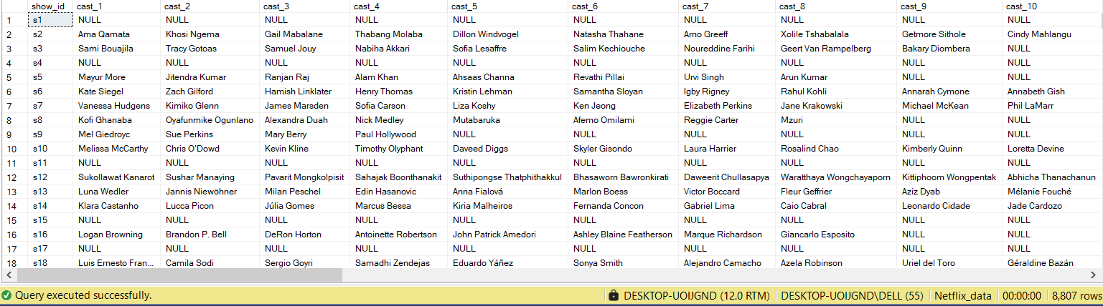

SELECT

*

FROM

[dbo].[Country];

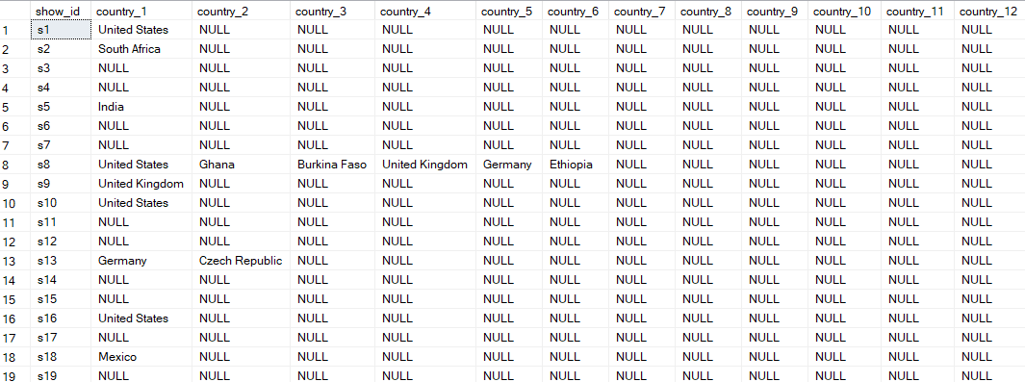

SELECT

*

FROM

[dbo].[Descrption];

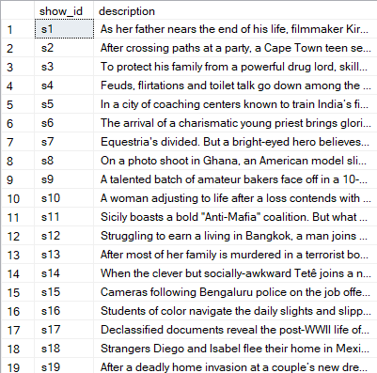

SELECT

*

FROM

[dbo].[Directors];

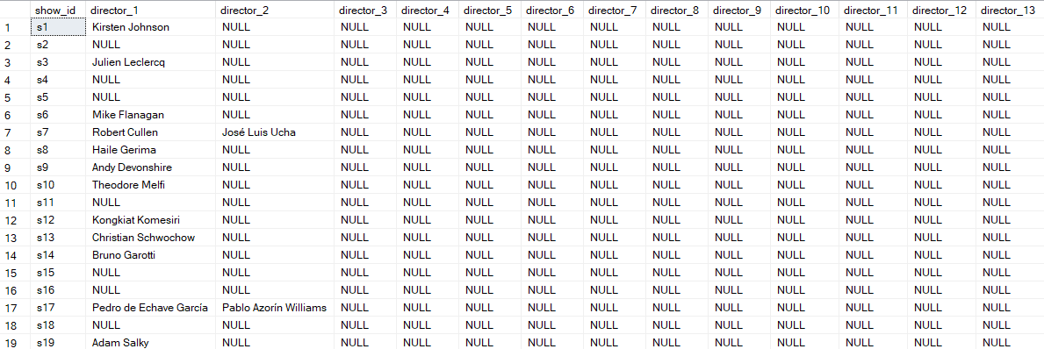

SELECT

*

FROM

[dbo].[Listed in];

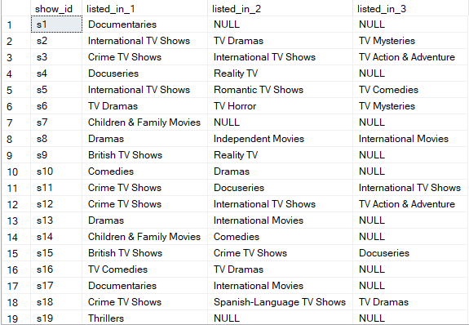

SELECT

*

FROM

[dbo].[netflix_titles ];

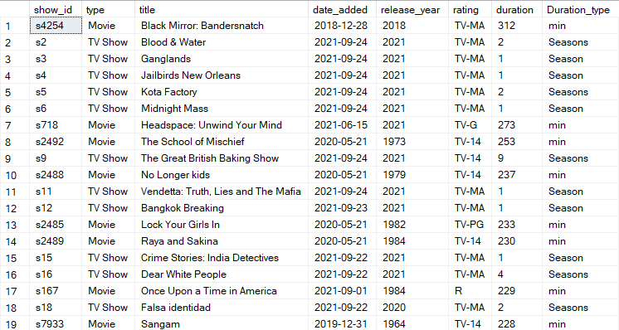

**I created a new table and unpivoted ‘cast’, ‘country’, ‘directors’, ‘listedin’, while also removing the ‘NULL’ rows. The SQL queries file is attached to the project document. Below are the results and queries after unpivoting the four tables listed above.**

SELECT

*

FROM

[dbo].[Netflix_cast];

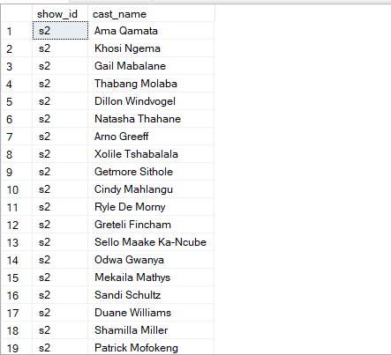

SELECT

*

FROM

[dbo].[Countries_released];

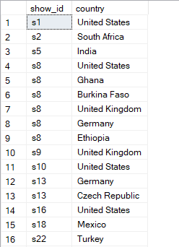

SELECT

*

FROM

[dbo].[Netflix_directors];

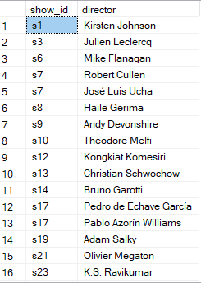

SELECT

*

FROM

[dbo].[Netflix_listedin];

